Writing an IIIF Client on a $40 Microcontroller
Fabrício Kury — DRAFT for Code4Lib Journal submission. Not submitted. Word count ≈ 4,400 (journal guidance: 1,500–5,000).
Abstract. p3a is an open-source desktop art frame built on a $39.99 ESP32-P4 development board with a 4-inch 720×720 touchscreen. Since May 2026 its firmware has spoken the IIIF Image API natively, pulling artwork from seven institutions: the Art Institute of Chicago, the Rijksmuseum, the Victoria and Albert Museum, the Wellcome Collection, the Statens Museum for Kunst, the Harvard Art Museums, and the Smithsonian. This article reports what the IIIF ecosystem looks like from an unusually small client. The finding is an asymmetry: the IIIF Image API delivered perfectly on its interoperability promise — one URL template serves pixels from all seven institutions — while everything above it (finding artworks, browsing collections, paginating results) required seven bespoke adapters against seven very different search APIs. I describe both layers, measure whether the IIIF Presentation API could have closed the gap (it could not, for reasons that are partly adoption and partly the specification itself), and end with a short list of inexpensive things an institution can do to make its collection usable by clients much smaller than a browser.

1. A very small patron
Seven museums will serve their collections, image by image, to a computer that costs less than most exhibition catalogs. I want to say at the outset that this is wonderful, and nothing in this article should be read as a complaint. Open-access programs and IIIF endpoints exist because people inside these institutions fought for them; what follows is a field report on what those endpoints look like from the far edge of their audience, with affection, from their smallest regular visitor.
The visitor is p3a, an open-hardware desktop art frame [1]. The hardware is a Waveshare ESP32-P4 development board called ESP32-P4-WIFI6-TOUCH-LCD-4B, which retails at the manufacturer’s website for $39.99 as of August 2026. Add a modest microSD card, USB-C power source and cable, and the whole build should stay under $70. The ESP32-P4 is a dual-core 400 MHz RISC-V microcontroller. It has no operating system beyond FreeRTOS and no browser stack. It enjoys 32 MB of PSRAM plus about 768 KB of internal SRAM, a hardware JPEG-like decoder, and Wi-Fi version 6 via a companion ESP32-C6 chip. The board carries a 4-inch, 24-bit, 720×720 IPS capacitive touchscreen. The firmware is C on ESP-IDF. p3a began as a pixel-art player and plays animations from Giphy and Klipy, artworks from Makapix Club (an open-source pixel-art community I also run), and files from its SD card. The museum feature grew out of a search for more things worth putting on a good square screen that sits next to you on your desk or shelf.
I should disclose the method of that search, because it is part of the story: p3a is developed end-to-end with LLM assistance: first with a variety of models (but mostly Anthropic’s) inside the Cursor IDE, later with Claude Code generally running the newest Opus-class model available at the time. When I wanted new content sources, I sent LLM agents to scour the web for candidates. One of them came back with something called the IIIF Image API. I had never heard of it. It is not an exaggeration to say that this article exists because a language model introduced me to a library standard.
What made IIIF remarkable, from where I sat, is the premise of this article. Integrating one museum’s images usually means integrating with one museum’s image infrastructure; IIIF meant that “integrate seven museums’ images” was one engineering task. But only for the images. Above the pixels — finding artworks, browsing collections, paginating — no such layer exists in practice, and each museum cost a separate adapter. One URL template, seven discovery layers. The rest of this article walks the two halves of that sentence.
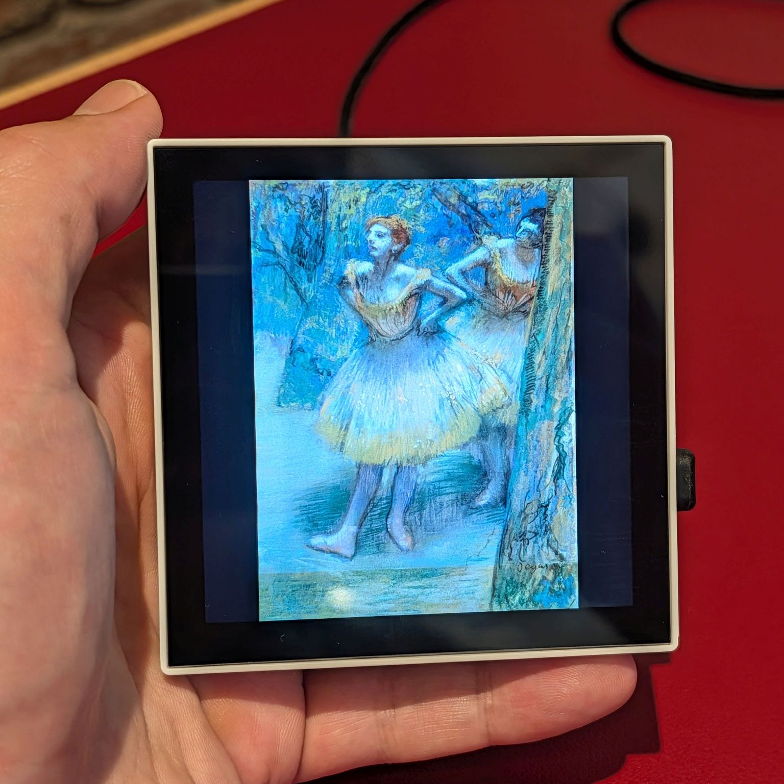
Figure 1. p3a displaying Two Dancers (Edgar Degas, c. 1893–98, pastel and charcoal; collection of the Art Institute of Chicago, CC0). The image on screen was requested from AIC’s IIIF endpoint at exactly the panel’s resolution. (File: images/photos/p3a-museum-channel-5.jpg; photo by the author.)

2. What the client needed
p3a’s abstraction for a source of artworks is the channel. For example, a channel can be a saved selection like “Art Institute of Chicago → Departments → Modern and Contemporary Art” or “Rijksmuseum → the curated set Paintings”. A channel for p3a is a list of artworks assumed to be very large, too large to obtain all at once. A user assembles channels in a small web app the device itself serves to a phone or laptop on the same wi-fi network. p3a can mix and match channels at different ratios of airtime. The firmware then keeps each channel stocked and periodically refreshes its listing every four days by default. As soon as listings have been obtained, p3a begins downloading images to a per-channel cache on the microSD card (1,024 artworks per channel by default) and rotates them on screen. Each artwork is displayed for 30 seconds by default. All these defaults can be configured.
Long before IIIF entered the picture, this design fixed what the discovery layer must provide. Three primitives, for every museum:
- List collections: whatever the museum’s own vocabulary of groupings is: departments, classifications, curated sets, administrative units.
- Enumerate a collection, with a total count, at an arbitrary offset: “artworks 400–499 of Paintings”, not merely “next page”. Counts and offsets matter because a channel can be configured to start deep in a collection, and because a device that caches 1,024 of 735,001 artworks needs to know both numbers.
- Yield an image identifier inline: each listing record must carry the key that unlocks pixels, without requiring a further per-artwork request.
Notably absent: artwork metadata. p3a displays images full-bleed and stores a 64-byte record per artwork (of which 48 bytes hold the image key), so titles and artists are, with regret, mostly dispensable. This austerity turns out to be analytically useful — it reduces “can a small client browse this museum?” to the three primitives above, making comparisons between museums, and between APIs and standards, unusually crisp.

3. The uniform layer
Once an adapter has produced an image identifier, museums stop being different from one another. The firmware builds
{iiif_base}/{identifier}/full/!720,720/0/default.jpg
and saves the response to the SD card. That is the entire institution-independent contract: IIIF Image API version 2, the bang-size syntax requesting a best-fit within 720×720, rotation zero, JPEG [2]. It worked, unmodified, on all seven services: Chicago’s in-house server, the Rijksmuseum’s images served by Micrio (a commercial deep-zoom vendor), London’s framemark host, Copenhagen’s IIPImage installation, Harvard’s delivery service, the Smithsonian’s IDS. Seven independently operated image stacks; one line of URL construction. Whatever else this article observes, that is a standards success story and the people who wrote and implemented the Image API deserve to hear it.
Three deliberate simplifications kept the uniform layer uniform:
No info.json. A capable IIIF client negotiates: fetch the image’s info.json, learn the sizes and features on offer, choose. p3a never does. The panel is 720×720, !720,720 has been found to be universally honored and skipping negotiation halves the request count. In fourteen months of operation this shortcut has not misfired once. Where advertisement and reality diverge, they diverge in the other direction (see SMK, below).
JPEG only. The ESP32-P4 has a hardware JPEG decoder, and museum IIIF servers serve JPEG far more reliably than WebP. (Honesty requires a caveat: progressive JPEGs and certain dimension combinations fall back to a software decoder, carefully fenced so a corrupt file cannot crash the device. “Hardware-decoded” is the happy path, not a guarantee.)
Stream, never buffer. Images move to the SD card in 32 KB chunks through a fixed-size buffer, written to a temporary file and renamed on completion. The device-wide budget is two concurrent TLS sessions; a 16 MiB cap guards against surprises. A client with 32 MB of total RAM does not get to “just download the image and see”.

4. The bespoke layer: seven discovery adapters
Above the Image API, each museum is its own scenario. The plainest evidence is the current line count of p3a’s per-museum adapters, each implementing the same three primitives against a different search API:
Adapter (C source) | Lines
Art Institute of Chicago | 839
Rijksmuseum | 645
Smithsonian | 526
Harvard Art Museums | 477
Wellcome Collection | 438
Statens Museum for Kunst | 406
Victoria and Albert Museum | 399
Shared IIIF helpers, used by all seven | 59
Fifty-nine shared lines cover everything the standard standardized. The other ~3,700 are the difference between “has an API” and “has the same API”. What follows are the exhibits I would show a visitor: each one a real behavior a client must handle, none of them documented failures, all of them observed politely from outside.

4.1 Art Institute of Chicago: the thousand-record wall
AIC’s is the best-documented museum API I found, and the adapter is still the longest. Two behaviors of its Elasticsearch-backed search explain most of it. First, anonymous callers discover (empirically, not from the documentation) that from + size on /artworks/search must stay at or under 1,000; deeper GET pagination is refused. Second, paging through very large facets (say, Painting) starts returning HTTP 403 past roughly page ten, independent of the first limit.
Reaching past that wall took the adapter’s one genuinely creative move. AIC’s search accepts Elasticsearch-style JSON query bodies via POST, and bool + range filters on the numeric artwork id are honored for anonymous callers. So when a channel needs artworks beyond offset 1,000, the adapter partitions the museum: it probes record counts (a size: 0 query costs almost nothing) and recursively bisects the artwork-id space until every bucket holds at most 1,000 records, then pages within buckets, all below the cap.
partition(lo, hi):
n = count(artworks with lo ≤ id < hi) # "size: 0" probe
if n ≤ 1000: emit bucket [lo, hi) # fits under the cap
else if hi−lo ≤ minimum span: emit anyway # give up narrowing
else: partition(lo, mid); partition(mid, hi)
A $40 device, in other words, performs adaptive query planning against a museum’s search engine: around sixty-four buckets, recomputed at each refresh because the collection moves underneath it. I am fond of this code and slightly discontent that it needs to exist.

4.2 Rijksmuseum: Linked Art, three hops down
The Rijksmuseum is the one museum of the seven whose discovery layer is itself standards-based: Linked Art documents, traversed as an OrderedCollectionPage stream [3]. It is also the adapter where p3a performs semantic-web resource traversal in firmware, because nothing in the listing carries an image identifier. For every artwork the client walks: HumanMadeObject → shows[] → VisualItem → digitally_shown_by[] → DigitalObject → access_point[], whose URL finally names the Micrio image id. Each hop is a separate JSON-LD fetch.
Three hops per artwork at listing time would be brutal, so the adapter resolves lazily: the refresh stores unresolved records, and the download loop resolves one artwork per pass, interleaved between image downloads. A record that fails resolution three times is tombstoned and skipped until a future refresh re-lists the artwork, which resets its budget. The cursor-only pagination also means the “arbitrary offset” primitive is emulated: the client reads the total from the stream’s metadata, wraps the offset into range, and pays ⌈N/100⌉ throwaway page fetches to reach it. Every cost in this paragraph is the honest price of the standards-based path, and section 5 returns to it.
One quirk deserves its own sentence: the museum’s curated set list — the entry point for browsing — is published over OAI-PMH without CORS headers, so a browser cannot fetch it; p3a therefore ships the set list baked into the firmware’s flash filesystem and serves it to its own configuration UI. The device carries a small copy of the Rijksmuseum’s table of contents wherever it goes, because of CORS headers.

4.3 Smithsonian: the WAF that says 200
The Smithsonian’s search API and image service both sit behind a web application firewall that rejects requests bearing an empty or default User-Agent. It rejects them with HTTP 200 and an HTML page reading “Request Rejected”. For a firmware client, the failure signature is therefore not an HTTP error but a JSON parse error on what claimed to be a successful response — among the most misleading failure modes encountered in this project. The fix costs one line: identify yourself (p3a/{version}, with a contact email), which is exactly what a WAF wants of a well-behaved bot. The lesson generalizes; the diagnosis, at 2 a.m., did not feel general.
Smithsonian records are also the largest of the seven — a nested metadata format in which fifty records can exceed half a megabyte — so this adapter alone budgets a full 1 MB response buffer, and its rights field turned out not to be indexed for filtering (a query AND-ing usage: CC0 silently matches nothing). And access requires a free api.data.gov key: the shared DEMO_KEY is rate-capped too low to survive a single channel refresh, a fact the settings UI explains to users.

4.4 Harvard, Wellcome, SMK, V&A: a quirk apiece
Harvard Art Museums taught the value of reading query parameters: without q=imagepermissionlevel:0, roughly half of the records flagged “has image” arrive without a usable image URL; permission-restricted at a layer the hasimage flag does not see. Harvard’s image “server”, meanwhile, is a URN resolver: the stored identifier is a URN, the IIIF path is appended to it, and a 303 redirect lands on the actual image host.
Wellcome Collection exposes stable ids for some facet axes and, for others (genres, subjects, contributors), filters by the label string itself. p3a stores channel identifiers in a 33-byte slot, so Wellcome terms with labels longer than 32 characters simply cannot become channels.
Statens Museum for Kunst is the friendliest API of the seven — true offset pagination, anonymous, clean JSON, with one perfect irony: its image server’s info.json advertises WebP and returns 400 when asked for it. The one museum where capability negotiation would have changed p3a’s behavior is the one where negotiation lies. Its search API also returns empty results if asked to trim response fields, so its metadata-rich pages must be swallowed whole (512 KB of buffer for fifty artworks).
The Victoria and Albert Museum is the shortest adapter and mostly just works, but computes count = 0 for one facet type whenever the has-images filter is applied, so the browse layer enumerates that facet unfiltered and re-probes each term individually to recover honest counts.
None of these institutions is doing anything wrong, exactly. Each API is internally coherent and most are genuinely good. The point of the catalog is the variance: seven reasonable APIs are still seven APIs, and the client pays for each difference in code, in buffer sizes sized to the most verbose page (192 KB to 1 MB, per museum), and in failure modes that must each be learned once, the hard way.

5. Could IIIF Presentation have been the missing layer?
A fair question at this point: IIIF has a second major specification, the Presentation API, whose Collections explicitly model “groups of things” [4]. My own early survey notes called it “strongly preferred… the natural carrier” for collection browsing. The shipped system uses none of it. Because the decision was made in the fog of development (with, candidly, an LLM’s hands on many of the levers), I re-examined it for this article with fresh probes of all seven institutions (2026-08-07). The answer is a confident no, on three independent grounds.
Adoption. Of the seven museums, exactly two publish a machine-discoverable IIIF Collection document, and both broke at precisely the level where enumeration would begin. Harvard advertises a Presentation collection root whose single child, Objects, returns HTTP 500. Wellcome — the strongest adopter, with a handsome top-level tree that even materializes facet axes as sub-collections — returned 503 for both facet children I probed. Chicago’s /iiif/2/collection URL is parsed by its image server as an image named “collection” (redirecting to an info.json that does not exist); the V&A’s manifest host has no collection surface; SMK advertises none; the Smithsonian’s documentation does not mention Presentation at all. Six of seven do serve lovely per-artwork manifests, but a manifest is addressed by an object id that only the search API can supply, so manifests presuppose discovery rather than provide it.
Specification. Even under perfect adoption, the current spec cannot express what a browsing client asks. Presentation 3.0 scopes itself to what a viewer needs to render an object, and says plainly that discovery and harvesting are not what it provides: its Collections are ordered trees of references, with no paging construct (version 2.1’s paging properties were removed), no item counts, no offset access, no facets, and no metadata search — search is delegated to the Content Search API, which searches annotation text within a single object, and cross-collection discovery to the Change Discovery API, a harvester’s feed that presumes the client maintains its own index. That last assumption deserves underlining: the IIIF discovery model is build a search engine, then query your copy. A microcontroller cannot be a harvester; it needs the institution’s index, queryable in place, which is exactly what every museum’s bespoke search API is.
Economics. Measured the same day: one bespoke search page delivers 50–100 artworks, with image identifiers inline, in 14–185 KB — Chicago manages about 142 bytes per artwork. The Presentation equivalent is a tree walk plus one manifest per artwork (2.5 KB at Chicago, 107 KB at Wellcome, where a single manifest weighs as much as an entire hundred-work catalog page). For a standard 1,024-artwork channel that is ten-to-twenty requests versus a thousand — a 50–100× multiplier for a client that pays TLS per request — and at the end of it the client still has no counts and no offsets.
The Rijksmuseum adapter, fittingly, is the exception that measures the rule: its Linked Art walk is the standards-based discovery path, working in production — at the price of cursor-only access, offset emulation, and three extra fetches per artwork. The conclusion I did not expect to reach: p3a’s split (bespoke search API for discovery, IIIF for pixels) is not a pragmatic betrayal of the standard. It is the division of labor the IIIF specifications themselves prescribe. The gap between “there should be a standard way to browse collections” and “there is one” is real, known to the IIIF community, and, as the adoption findings above suggest, unlikely to be closed by Presentation Collections as they stand.

6. Being a polite client
A device that lives in living rooms and refreshes museum APIs on a timer had better be a good citizen, and several of p3a’s mechanisms exist purely for politeness. They double as a working example of what “a well-behaved small client” can mean, so I list them.
Identify yourself. Every request carries an identifying User-Agent with a contact email (Chicago asks for this explicitly via a custom header; the Smithsonian, as noted, enforces the spirit of it with a firewall).
Honor Retry-After, remember it, share it. Each museum has a cooldown slot on the device; any HTTP 429 engages it — honoring Retry-After when present (capped at an hour), defaulting to sixty seconds otherwise — and every layer that issues requests (refresh, downloads, the Rijksmuseum resolver) checks it before dialing out. Cooldowns only extend, never shorten.
One budget per household. The subtle one: p3a’s browse UI runs in the user’s browser and queries museum APIs directly, so browser and device share one public IP and museum rate limits are per-IP. The two halves therefore share the budget explicitly: when the browse UI receives a 429 from a museum, it reports it to the device (POST /api/museum/rate-limits/report-429), engaging the same cooldown the device’s own traffic would; before expensive browse operations, the UI polls the device’s cooldown table and waits its turn.
Pace even when allowed. Page fetches during refresh sleep 150–200 milliseconds between requests; browse-time probes cap their concurrency; the whole device allows itself two TLS connections at the same time. A full channel refresh costs roughly 41–82 API calls against daily quotas of 1,000–2,500 where quotas exist, and runs every four days.

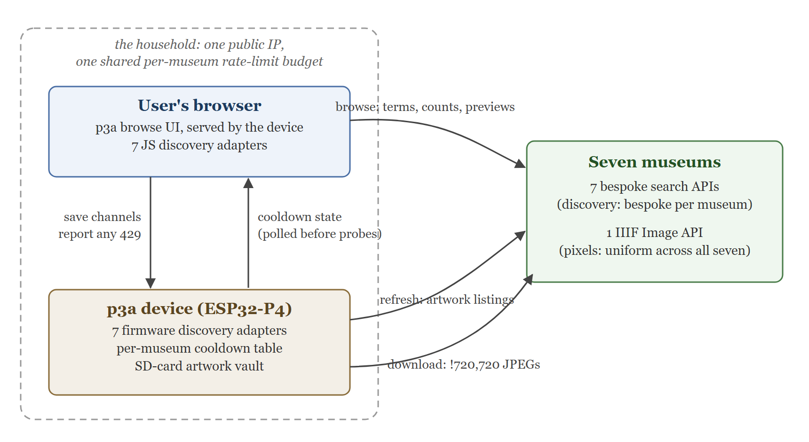
Figure 2. Discovery, delivery, and the shared rate-limit budget: the browse UI (in the user’s browser) queries museum search APIs directly and reports any 429 to the device; the device refreshes listings, downloads images over the IIIF Image API, and holds the per-museum cooldown table both halves consult. (File: figure-2-architecture.svg in this folder; to be rasterized to PNG ≤500 px for submission.)

7. What a 64-byte budget clarifies
p3a stores each artwork as a 64-byte record: a hash, dimensions, a timestamp, one byte for file type, and 48 bytes for the museum’s image identifier. This budget directly translates into how many artworks the device can rotate simultaneously (by design, p3a is limited to simultaneously playing 64 channels with 4,096 artworks each). There is something clarifying about a budget this tight: it converts vague API preferences into sharp, testable requirements, and I offer the conversions as data points from the small end of the client spectrum:
- Identifier length is an interoperability property. Chicago’s image UUIDs (36 characters), Harvard’s URNs (about 25), Micrio’s short ids (about 8) all fit in 48 bytes; anything longer is silently unusable. When Wellcome filters by label instead of id, the limit bites visibly (§4.4).
- Identifier stability is one too. The record survives firmware updates, cache rebuilds, and re-listings; identifiers that drift orphan their own files.
- One byte of state is enough — barely. The file-type byte moonlights as the Rijksmuseum resolver’s state machine: two reserved values mean “not yet resolved” and “given up”. When a re-listing offers an unresolved record where a resolved one already sits, the merge must decline the downgrade or it would orphan the very file it already downloaded. Every embedded byte ends up doing two jobs.
- Verbosity is a tax paid in RAM. The spread between Chicago’s 142 bytes per listed artwork and SMK’s ~3,700 is, on a laptop, invisible; on this device it is the difference between a 192 KB and a 512 KB parse buffer, allocated for the lifetime of a refresh. Furthermore, not all RAM in the ESP32-P4 device are equal, and at times parts of the computations can only be done using internal SRAM (768 KB) as opposed to PSRAM (32 MB).
None of this asks museums to design for microcontrollers. It asks something cheaper: that the properties small clients depend on — short stable ids, lean listings, honest capability advertisements — be recognized as compatibility surface, not implementation detail.

8. Discussion: what would help, and what is changing
Distilled from seven integrations, a short generic checklist. Every item on it already exists in at least one of the seven APIs, so this is curation not invention:
- Inline image identifiers in search results. The single biggest determinant of client cost. One field turns N+1 requests into 1.
- True offset pagination with totals. Cursors force sequential walks; caps that appear only empirically force adapters to learn them empirically.
- A filter meaning “displayable image actually included”, that composes with other filters and reflects permissions, not just file existence.
- Retry-After on every 429. Clients that want to comply can only comply with what is stated.
- Reject loudly. An HTTP error for a rejected request; a WAF that says 200 turns every downstream parser into a liar.
- Advertise only what is served. An info.json is a promise, and small clients are the ones that believe it.
- Document the sharp edges. Result-window caps, key-quota floors, permission gates. Every undocumented limit in this article was learned by trial and error.
Two broader observations from the 2026 landscape, briefly. First, museum APIs are mortal: in the months around this writing, NYPL’s Digital Collections API was retired and several smaller museum APIs quietly died; any client that embeds institutions must plan for their endpoints’ absence (p3a carries per-source kill switches). Second, bot defense is becoming a first-class compatibility issue: WAFs and fingerprint-based challenges now front several otherwise-open cultural APIs, and a legitimate small client is collateral unless “identify yourself honestly” remains a sufficient answer. Both trends raise the value of everything IIIF got right. The Image API’s uniformity is precisely what makes a seven-museum client maintainable by one person and their language models.
As far as I have been able to determine — searching discuss.iiif.io, the IIIF Consortium’s news archive, this Journal’s back catalog, and the open web — no prior IIIF Image API client implemented in microcontroller firmware has been described.

9. Conclusion
The IIIF Image API kept a promise: seven institutions, seven image stacks, one line of client code. The discovery layer above it remains a per-museum negotiation, not because museums ignored a standard, but because the standard IIIF offers there is scoped for viewers and harvesters, not for small clients asking contained questions (“what’s in this particular collection? how many? give me items 400–499”). A $40 microcontroller turns out to be a usefully honest instrument for measuring that gap: everything implicit becomes a buffer size, a request count, or a byte.
The frame on my desk was showing a Degas pastel it fetched from Chicago this morning, sized to the pixel, over an API someone maintains so that anyone, apparently including a microcontroller, can ask. Next on its roadmap is the Cleveland Museum of Art, whose API ranks, by measures developed here, friendlier than some already shipped. The queue of museums worth thanking is not getting shorter.

Acknowledgments and disclosure
p3a is open source (Apache 2.0) at https://github.com/fabkury/p3a; the seven adapters described here are in components/art_institution/. The project and this article’s endpoint probes of 2026-08-07 were produced with substantial AI assistance: development in the Cursor IDE (using a variety of models, including Anthropic’s) and with Claude Code (primarily the newest Opus-class model available at the time). This article was likewise drafted with AI assistance and fully revised by the author, who verified the technical claims and takes sole responsibility for the content. The author has no financial interest in any product, service, or institution discussed; p3a and Makapix Club are noncommercial open-source projects; the author has no affiliation with Anthropic, Cursor, or any museum named.

About the author
Fabrício Kury (fab@kury.dev, github.com/fabkury) is a biomedical informatician in New York City. He currently works with Medicare claims data analytics at Sparx, Inc.

References
(CSE style to be finalized at submission; URLs verified 2026-08-08.)
[1] Kury F. p3a: Wi-Fi pixel art player. https://github.com/fabkury/p3a
[2] Appleby M, Crane T, Sanderson R, Stroop J, Warner S. IIIF Image API 3.0 (and 2.1). IIIF Consortium. https://iiif.io/api/image/
[3] Rijksmuseum. Collection data & APIs. https://data.rijksmuseum.nl/
[4] Appleby M, Crane T, Sanderson R, Stroop J, Warner S. IIIF Presentation API 3.0. IIIF Consortium. https://iiif.io/api/presentation/3.0/
[5] Art Institute of Chicago. API documentation. https://api.artic.edu/docs/
[6] Victoria and Albert Museum. Collections API. https://developers.vam.ac.uk/
[7] Wellcome Collection. Catalogue API. https://developers.wellcomecollection.org/
[8] Statens Museum for Kunst. SMK API. https://api.smk.dk/api/v1/docs/
[9] Harvard Art Museums. API documentation. https://github.com/harvardartmuseums/api-docs
[10] Smithsonian Institution. Open Access API. https://edan.si.edu/openaccess/docs/
[11] IIIF Consortium. Change Discovery API 1.0. https://iiif.io/api/discovery/1.0/

